Luke alone describes the mysterious affair at Emmaus. Mark alludes to it, but only Luke tells the story, and he does so in such a way that one commentator has said that it is one of his best sketches of a biblical scene; another says it is one of Luke’s most exquisite literary achievements.
How could we argue that point? Luke makes us feel as if we were present for these events: the chance encounter on the road, the outpouring of emotion and admiration of the stranger’s knowledge and understanding; the poignant plea for him to stay with them at the inn; the surprise of recognition; and finally the sudden disappearance.
Carl Jung wrote that the story is an example of the mythic dream theme of the magical traveling companion. I trust that the reference to myth and magic doesn’t put you off: I find it immensely valuable, as it reminds us that some of our most profound dreams seem as real as any events in our outer lives and that some of the most powerful moments in our conscious lives are imbued with a dreamlike quality.
Whatever we, or biblical scholars, or psychologists, or theologians might say, there is no denying that this biblical story is unique in its content and its impact.
We read the story on this day—the third Sunday of Easter—once every three years. It is full of emotion—fear, wonder, disappointment, gratitude, love, joy, and hope.
Maybe that’s why so many artists through these twenty centuries have chosen to depict it in one medium or another.
And now we get to something I’ve wanted to do for the past 45 years, but I’ve never been able. I’ve never had a projector and screen in the nave of a church. (Never particularly wanted one, for that matter.) I’ve never had the technology to put an image in front of a congregation.
About the closest I’ve ever come was my reproducing a Peanuts cartoon on poster-board size frames in a 1980 sermon. It was something about the dangers of fundamentalism told by Schulz’s character Peppermint Patty.
But I digress.
Because of our current situation and the technology we’re all learning, I can indeed show you a painting I’ve talked about almost every time this reading has come up in the lectionary. I first saw it while working on a paper in seminary; it was about the Holy Eucharist in art. I’ve mentioned it to you before, and I’m sure many of you have encountered it on your own; it’s Caravaggio’s Supper at Emmaus, painted in 1601. Here it is.
No, wait. First I want to show you an earlier depiction of the Emmaus scene, this one a relief carved in ivory in the late 9th or early 10th century. I’ve chosen it because in my minimal peek into the matter, it’s the earliest piece I found:
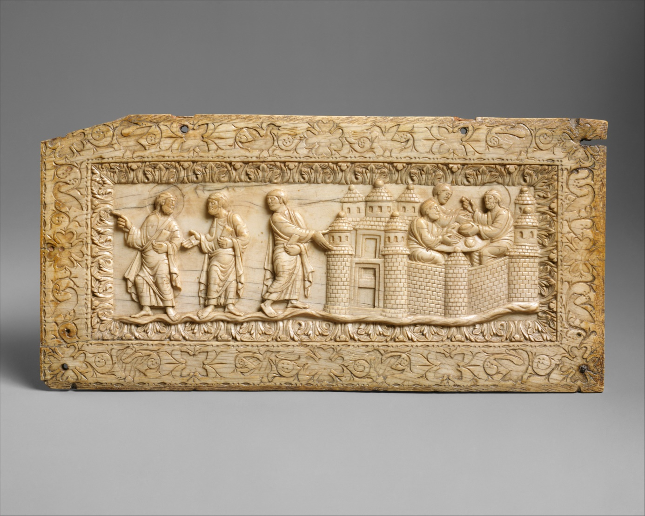
It begins at an earlier part of the story than the scene painted by Caravaggio. It’s almost like a story-board itself, and shows so clearly two of the main events in this encounter: at the left, the conversation and prelude to the “decision” by the risen Christ to go to the inn with the disciples. On the right, we see the three at the table together perhaps just before the recognition of the Lord by his fellow travelers.
The French artist draws attention to the hands in the scene by making them outsized: at the left, Jesus pointing in the direction in which he tells them he’s going; next to him, the man imploring him to accompany them—his outstretched hand is a familiar gesture by someone trying to make a point; and the last of the three pointing toward the inn where they hope this intriguing character will continue their conversation.
Then look at the hands in the right side of the scene, inside the inn, at table. Jesus is making the sign of blessing over the bread; the other two have their hands extended, palm upwards, as if to receive—the bread and the blessing.
There’s so much more here, and I’ve made no attempt to really delve into the history or the interpretation of the work. This is just my impression as one who is grateful that it is preserved for us. It’s all the more amazing when we consider that it is carved on a piece of ivory just 4 ½ by 9 ¼ inches.
Now, Caravaggio: He has chosen a particular moment at the table. It seems to me to be an instant later than the moment in the ivory relief. It’s the moment of recognition. Take a look:
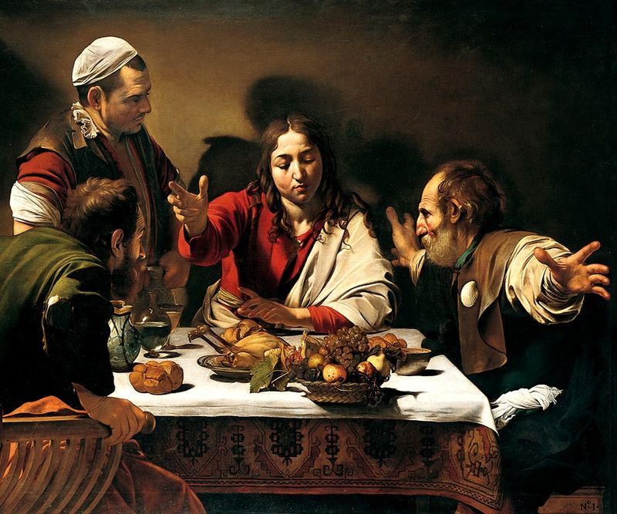
Evidently some commentators and art critics have called this one of the greatest paintings of all time. It is, before any other consideration, simply a thing of beauty—shadow and light, texture, color, movement. But for us, particularly, who continue to follow this Jesus, it is revelatory. It shows the surprise, the shock, the hint of joy (because I think that’s the next moment, the one after this one). The character on the right, his arms akimbo, is in a classic posture of . . . what? . . . awe? The one on the left is coming up out of his seat, he’s so amazed and unable to . . . well, to keep his seat. Some critics have said that the man serving them, maybe because he’s not a believer himself, simply doesn’t see what they see. Or maybe it’s just going to take him a little longer.
I wasn’t aware, until I was poking around on the internet (or I had known but forgotten) that Caravaggio did another painting of this scene six years later. The other was painted in 1660, this in 1666:
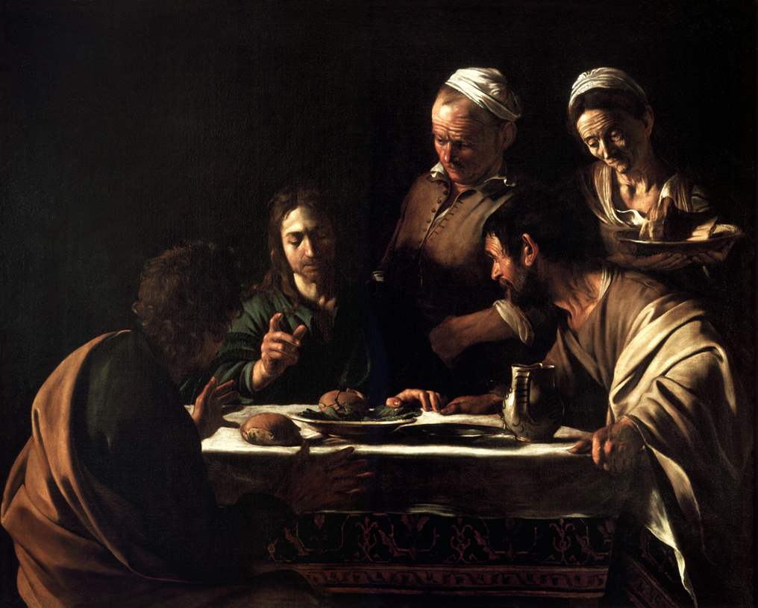
Look how much more subdued. And even though I said “the same scene,” I actually believe this is just a nanosecond earlier. It’s filled—I think—with anticipation rather than recognition. I wonder why, with six years’ more experience and life, Caravaggio decided to paint this scene. I could probably give you a better idea, had I decided to dive into historical biographical material, but frankly I didn’t want to. I’d rather imagine that the somewhat more mature painter had come to some kind of appreciation for, or wonder about, anticipation as juxtaposed to realization.
It is in its own right a deeply moving painting. Less light, less contrast, less of everything, it seems, in terms of emotion. It looks to me like the continuation, the last bit of teaching before the big moment.
Finally, I’d like to show you one more rendering of this scene partly to show how we continue to seek to make sense of the story of Jesus, to find that story in our own lives and culture. I know nothing about this artist; once again, I have deliberately remained ignorant of any details about him—Joe Forkan, who has done a complete cycle of classic paintings using characters from one of my favorite movies:
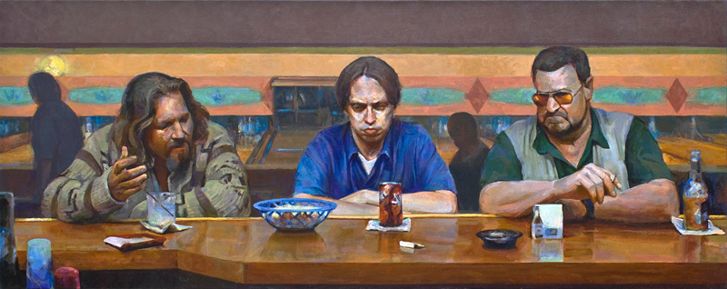
The Big Lebowski, which is one of those raunchy ones that I do not necessarily recommend to this audience in general. But I love it!
My point in including it is to say that in this thousand-plus span of years we see attempts to do what Jesus did. I don’t mean just showing us the scene of what Jesus did in this story told by Luke. I mean more generally what Jesus did by painting scenes with words in order to help his followers understand—more than that, to take into themselves—the reality of God’s love.
In fact, we can add that to the dreams-like-life and life-like-dreams analogy I made earlier. Jesus did the same thing with parables: those stories seemed like scenes out of the lives of his listeners on one hand and like dreams they had had on the other.
In terms of all of it—dream, story, painting, sculpture—we look for Jesus in our lives, often without even knowing that that’s what we’re doing. Sometimes it feels like tantalizing anticipation, sometimes like a sudden flash of recognition, sometimes like having a drink with friends at the bowling alley. In familiar and surprising circumstances, as we say in the Prayers of the People we find and are found by him.
+ + +

